I’m translating English to [ ]

(please write which language you’re translating!!)

Few words from Anne:

Thank you sooooo much for saying yes for the help!!!! I REALLY appreciate it!

The translations don’t need to be super strict and accurate,

(well if you can it def works better but don’t be stressed about it) all good as long as that makes sense to native speakers

AND if you don’t have the exact word or sentence/or hard to translate into one word/sentence, just leave it [blank]

Thanksss and ask me any questions if u guys havee!!

Let’s get this doneee >>>>>>>

NO NEED to be translated. Just for reference/context

Need to be translated! Actual sentences that being translate

**Screen #1 Language selection**

**Tone: Friendly :)**

*- Before we get started…*

*With which languages can you communicate?*

*What’s your language(s)?*

*- I can communicate with…..*

*(After selection)*

Sounds perfect!

OR

That’s awesome!

☺ ***Your translation here:***

太好了！

听起来不错！

**Screen #2 Pre-game**

**Tone: Friendly :)**

Hello and welcome to (game title)!

Let’s dive into the language ocean, shall we?

* I’d like to start with *word game.*
* I love challenges! Let’s go with *sentence game.*

☺ ***Your translation here:***

欢迎来到【游戏名】。

事不宜迟，让我们一起潜入语言之海吧！

* 出发！开始单词关卡！
* 前进，我要挑战自我！开始句子关卡！

**Screen #2.5 During the game**

**Tone: Friendly :)**

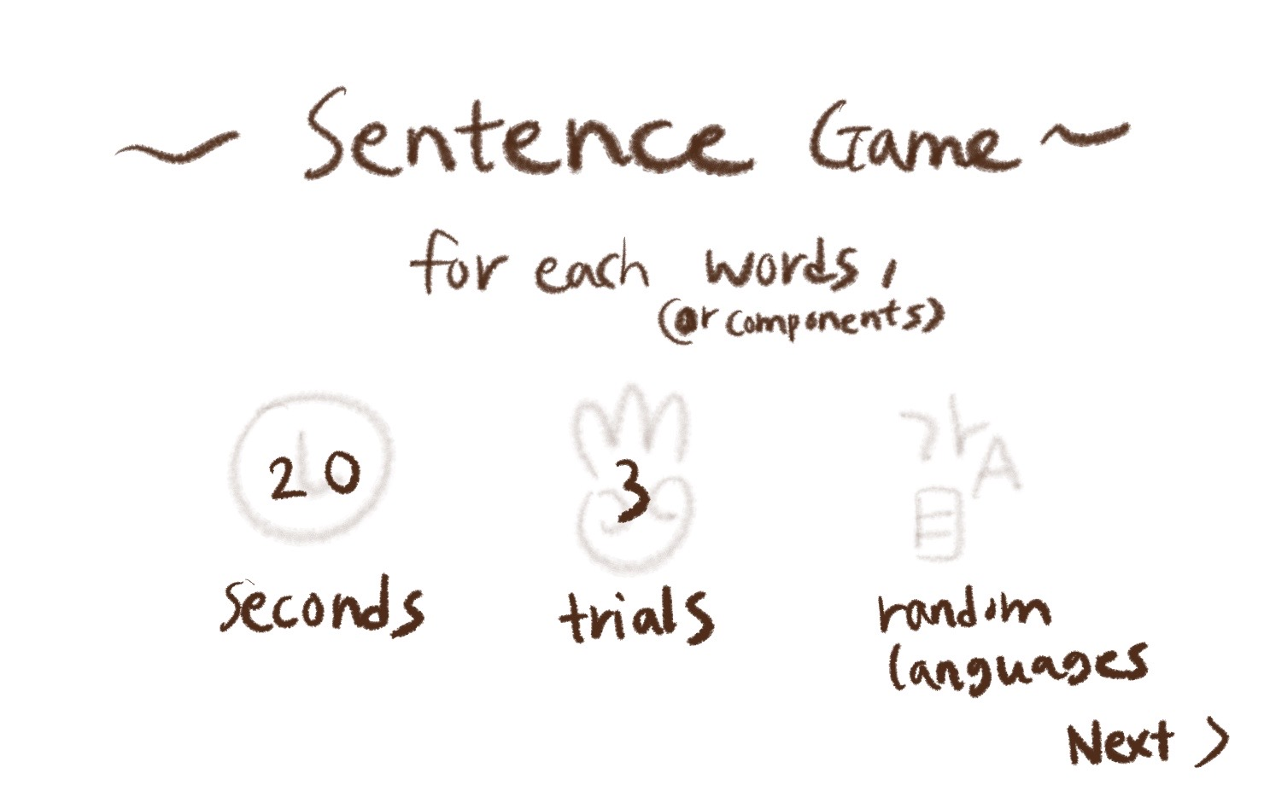

(The screen will be like this!!)

For each word, (OR components) ☺ ***Your translation here: 每个字词***

Trials (OR CHANCES) ☺ ***Your translation here: 次数***

Seconds (AS TIME) ☺ ***Your translation here: 时间（单位：秒）***

Random Languages ☺ ***Your translation here: 语言随机***

___________________________________________

What do you think it means?

☺ ***Your translation here: 你猜猜这是什么意思***

Type… (AS A ‘TYPE HERE’)

☺ ***Your translation here: 在此输入。。。***

You got it right!

☺ ***Your translation here: 恭喜你回答正确！***

For the first trial, you wrote:

For the second trial, you wrote:

For the third trial, you wrote:

☺ ***Your translation here:***

***你第一次写的：***

***你第二次写的：***

***你第三次写的：***

The answer was ___ .

☺ ***Your translation here: 正确答案是【】。***

next >>

(THIS IS A BUTTON FOR THE NEXT GAME)

☺ ***Your translation here: 前进 or 下一关（next level）or下一题（next question）***

You were so close!

(IF THE PLAYER DIDN’T GET THE ANSWER)

☺ ***Your translation here: 就差一点点！***

HOORAY!

You finished the game.

((OR)) That’s the end of the game.

(IT’S OKAY IF ‘HOORAY’ COULD NOT BE THE SAME IN YOUR LANGUAGE.

EXCITEMENTS LIKE ‘YEY!’ WOULD BE AWESOME.)

☺ ***Your translation here: 完美，你成功通关了整个游戏！***

Back to game >>

(RETURNING BUTTON)

☺ ***Your translation here: 继续 （continue the game），回到首页（back to lobby）***

**Screen #3 Word game**

**Tone: dictionary form**



Apple

☺ ***Your translation here:苹果***



wave

☺ ***Your translation here: 波浪***



Shopping bag

☺ ***Your translation here:购物袋***



introduce

☺ ***Your translation here: 介绍***

coffee

☺ ***Your translation here: 咖啡***

**

frozen

☺ ***Your translation here: 冻结***

**

photography

☺ ***Your translation here:摄影***



Reject

☺ ***Your translation here: 拒绝***



Love

☺ ***Your translation here: 爱情***



Water

☺ ***Your translation here: 水***

**Screen #4 Sentence game**

**Tone: dictionary form**

Instruction:

So what I’m gonna do here is making a sentence game with each different language for each component.

For instance:

I / 사과 / 好きです

apple(in KR) like(in JP)

= I like apple.

So please write it into two forms if it’s possible:

Top one: as a sentence

Bottom one: dictionary form for each components

If your language has a different grammar, you don’t need to follow the separation and the order I gave, just classify them as they are :)

Also, those sentences contain some humors lol

I love to procrastinate.

I / love / to / procrastinate

☺ ***Your translation here(AS A SENTENCE):我/爱拖延。***

☺ ***Your translation here(SEPARATED COMPONENTS):***

***我 / 爱 / 拖延***

***I / love / procrastination.***

I want a green apple.

I / want / a green apple

☺ ***Your translation here(AS A SENTENCE): 我想要一个青苹果。***

☺ ***Your translation here(SEPARATED COMPONENTS):***

***我 / 想要 / 一个 / 青苹果。***

***I / want / a (one) / green apple.***

Don’t make me run.

Don’t / make / me / run

☺ ***Your translation here(AS A SENTENCE): 别让我跑。***

☺ ***Your translation here(SEPARATED COMPONENTS):***

***别 / 让 / 我 / 跑。***

***Don’t / make / me / run.***

I would like to have one cute cat, please.

I / would / like to / have / one cute cat /, please

☺ ***Your translation here(AS A SENTENCE): 我想要一只可爱的猫。***

☺ ***Your translation here(SEPARATED COMPONENTS):***

***我 / 想要 / 一只 / 可爱的 / 猫***

***I / want / a / cute / cat.***

I have zero in my bank account.

I / have / zero(nothing) / in / my / bank account

☺ ***Your translation here(AS A SENTENCE): 我的银行账户里面空空如也***

☺ ***Your translation here(SEPARATED COMPONENTS):***

***我的 / 银行 / 账户 / 里面空空如也***

***My / bank / account / is empty (has no money in it)***

At least I have my sandwich with me.

At least / I / have / my / sandwich / with me

☺ ***Your translation here(AS A SENTENCE): 至少我还有我的三明治。***

☺ ***Your translation here(SEPARATED COMPONENTS):***

***至少 / 我 / 还有 / 我的 / 三明治。***

***At least / I / still have / my / sandwich.***

I love lying in my bed all day.

I / love / lying in / my bed / all day.

☺ ***Your translation here(AS A SENTENCE):我喜欢整天都躺在床上。***

☺ ***Your translation here(SEPARATED COMPONENTS):  
我 / 喜欢 / 整天都 / 躺在 / 床上。***

***I / like / all day / lay / on the bed.***

I woke up at 5:00pm.

I / woke up / at / 5:00pm.

☺ ***Your translation here(AS A SENTENCE): 我五点起的床。***

☺ ***Your translation here(SEPARATED COMPONENTS):  
我 / 下午五点 / 起的 / 床。***

***I / at five in the afternoon / got out of / bed.***

***THATS ALL FOR TRANSLATION!! YEY***

***And JUST FOR FUN, if you’d like to share:***

Words/expressions/sentences that doesn’t exist in English?: 麻烦 it basically means 귀찮아

太麻烦了我不想做=its too much work, I don’t want to do it

加油！

It means something like 頑張って, which does not have a direct translate to English.

It also means fill your car with gas,

(For instance, ‘귀찮아(gwichana)’ in Korean means ‘that’s too much work so I would rather not do it’ but the dictionary says ‘its annoying,’ which is not a good refleciton 😂)